Issue1: When clicked on “Wrong Network”

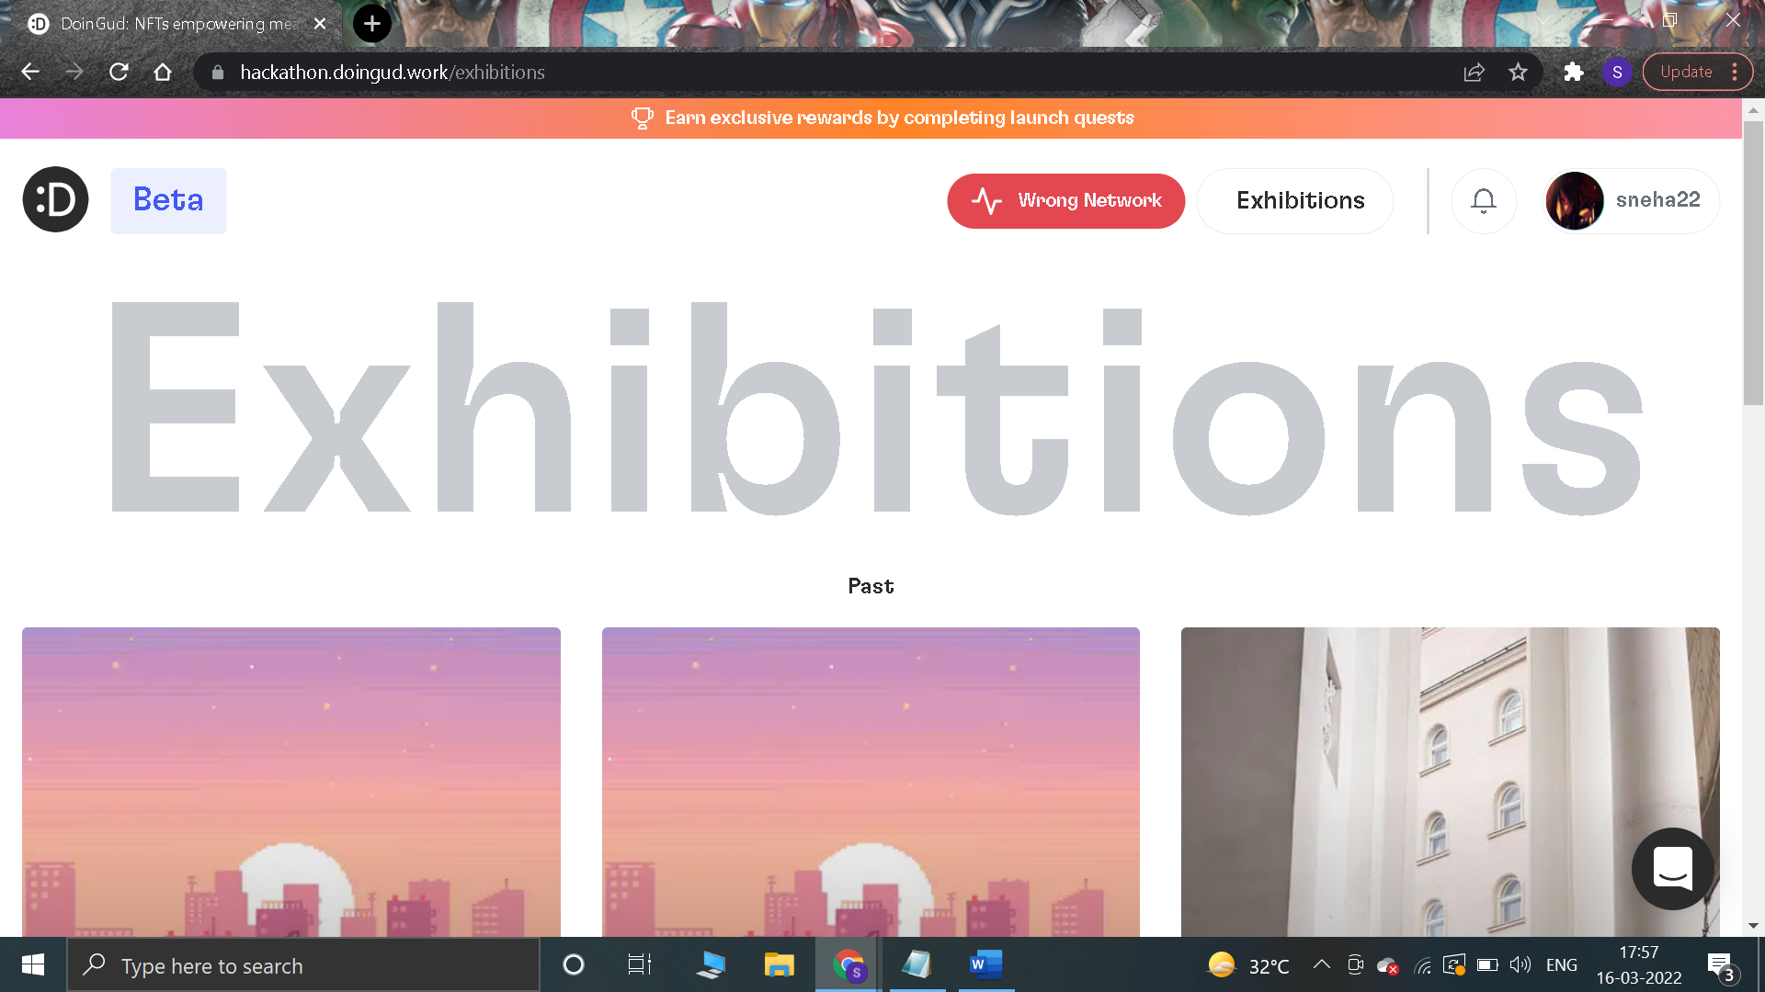

Below error appears and the connection is lost. But on refreshing, the above screen reappears with the Wrong Network button again.

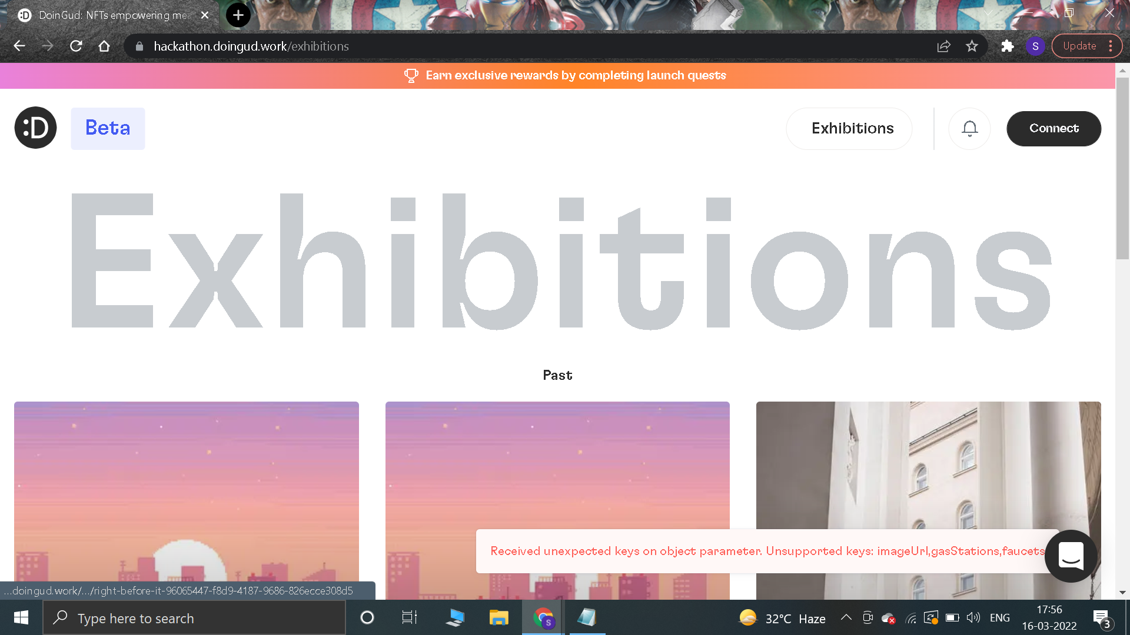

Issue 2: Not sure if this is browser related or issue in beta version, but the texts are overlapping in WalletConnect pop up

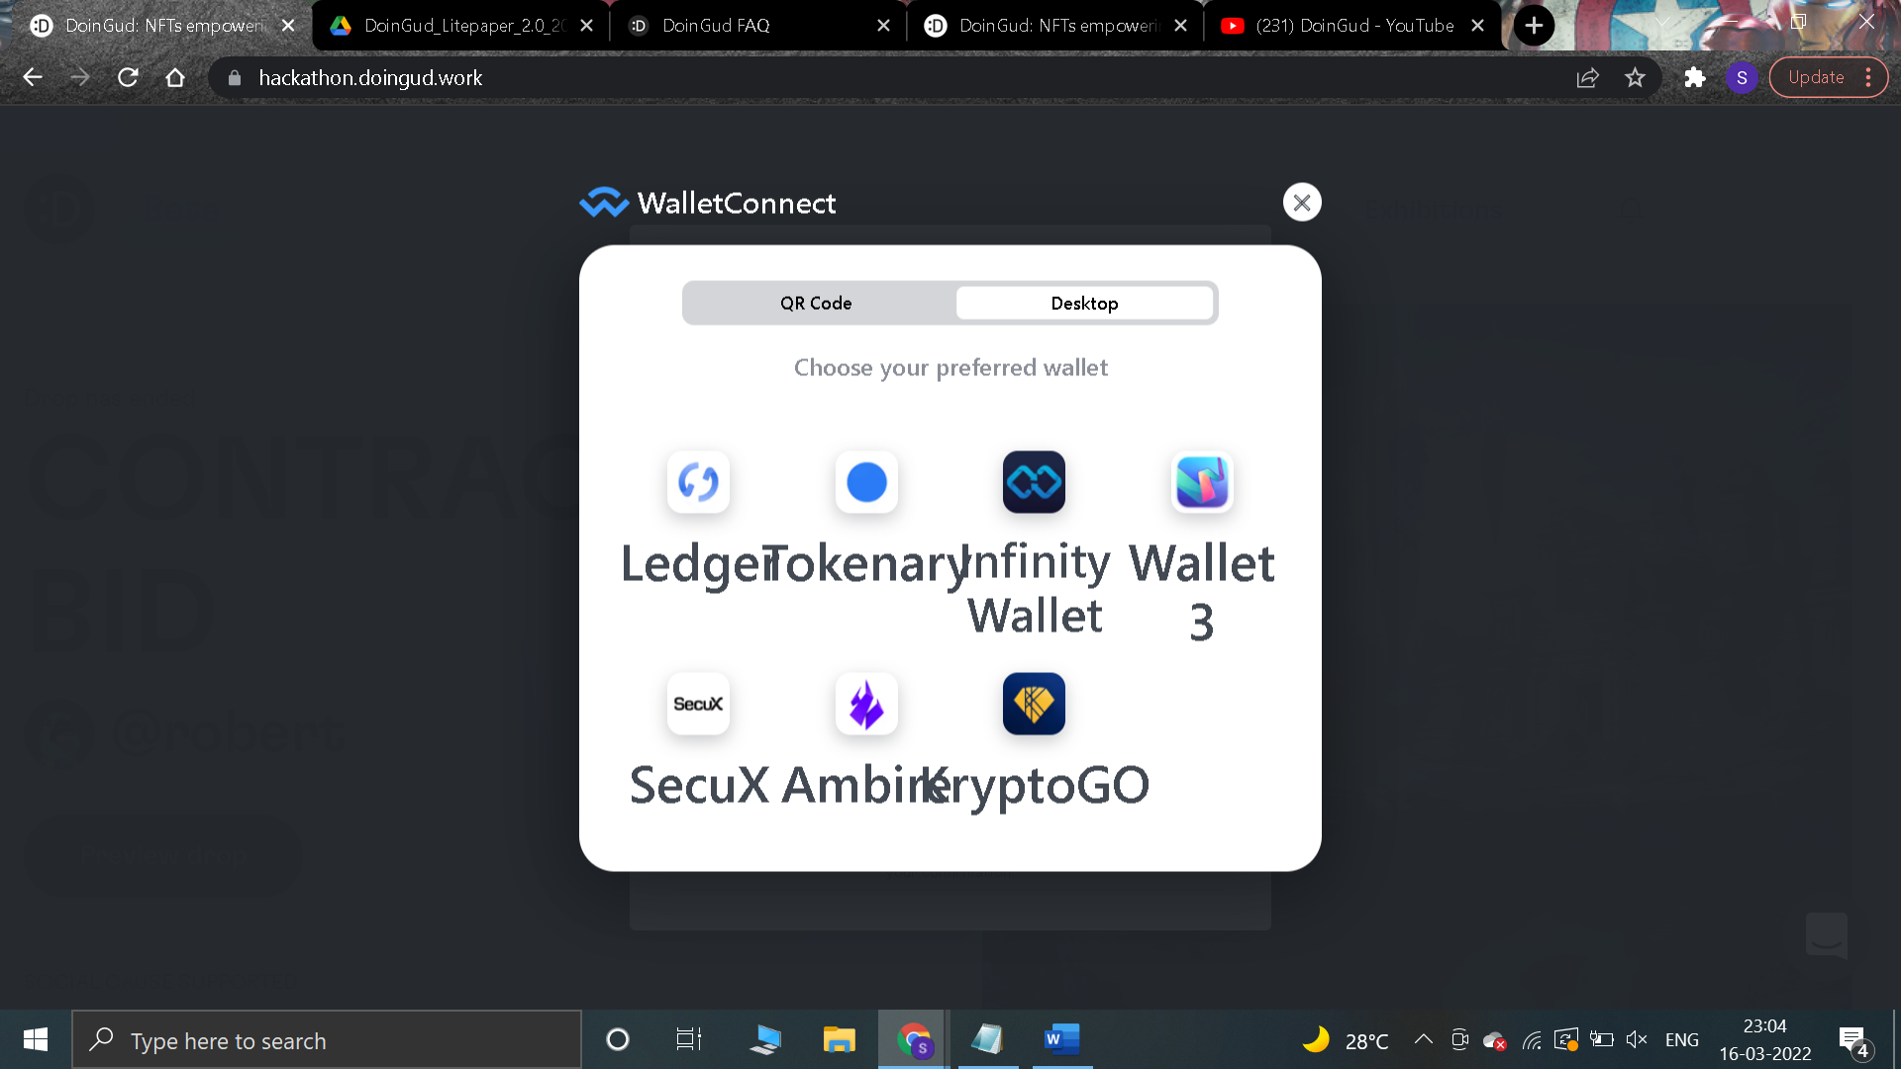

Issue 3: While running the script, when clicking on Connect, either the Metamask icon keeps loading or never appears.

